Customer Shopping Behaviour Analysis
1.Project Overview
This project analyses customer shopping behaviour using transactional data from 3,900 purchases across various product categories. The goal is to uncover insights into spending patterns, customer segments, product preferences, and subscription behaviour to guide strategic business decisions.
2. Dataset Summary
- Rows: 3,900
- Columns: 18
- Key Features: - Customer demographics (Age, Gender, Location, Subscription Status) - Purchase details (Item Purchased, Category, Purchase Amount, Season, Size, Colour)
- Shopping behaviour (Discount Applied, Promo Code Used, Previous Purchases, Frequency of Purchases, Review Rating, Shipping Type)
- Missing Data: 37 values in Review Rating column
3. Exploratory Data Analysis using Python
We began with data preparation and cleaning in Python:
● Data Loading: Imported the dataset using pandas.
● Initial Exploration: Used df.info() to check structure and df.describe() for summary statistics.
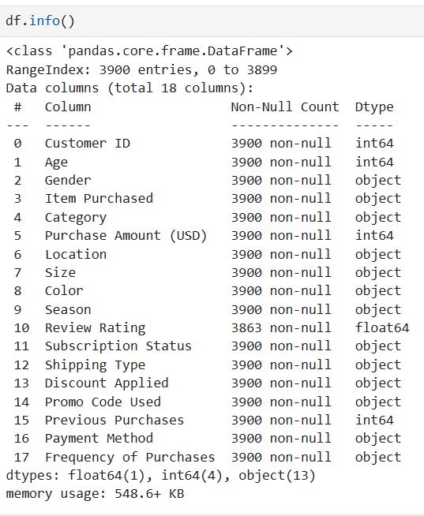

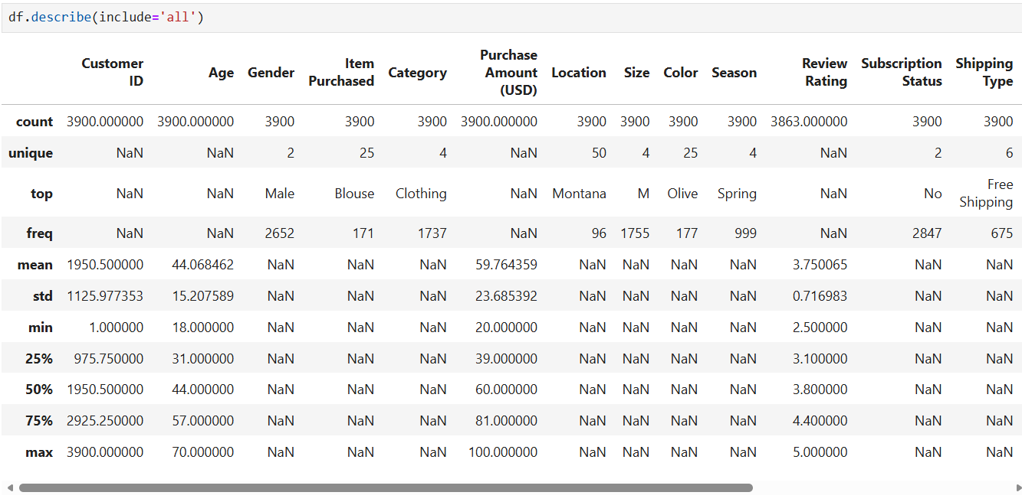
● Missing Data Handling: Checked for null values and imputed missing values in the Review Rating column using the median rating of each product category.
● Column Standardization: Renamed columns to snake case for better readability and documentation.
● Feature Engineering:
○ Created age_group column by binning customer ages.
○ Created purchase_frequency_days column from purchase data.
● Database Integration: Connected Python script to PostgreSQL and loaded the cleaned DataFrame into the database for SQL analysis.
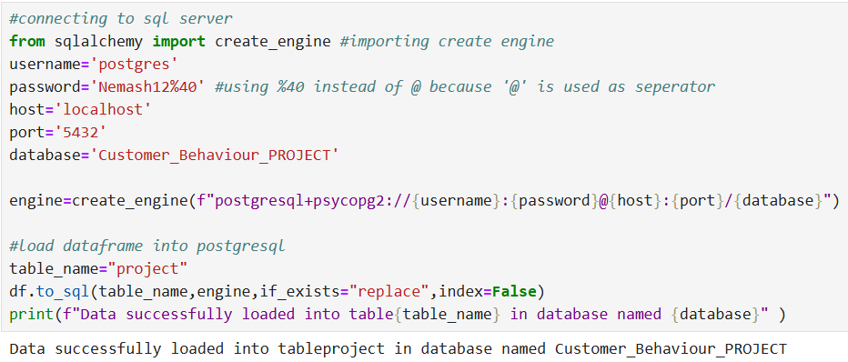

4. Data Analysis using SQL (Business Transactions)
We performed structured analysis in PostgreSQL to answer key business questions:
1.Revenue by Gender – Compared total revenue generated by male vs. female customers.

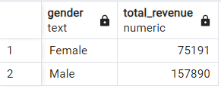

2. High-Spending Discount Users – Identified customers who used discounts but still spent above the average purchase amount.
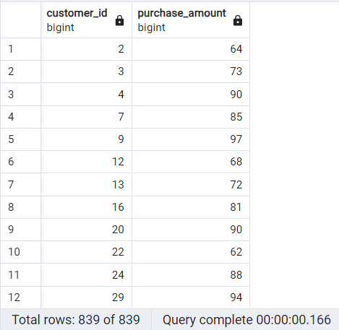

3. Top 5 Products by Rating – Found products with the highest average review ratings.
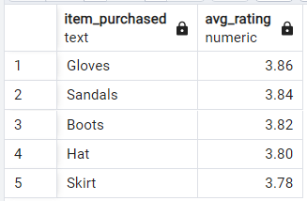

4. Shipping Type Comparison – Compared average purchase amounts between Standard and Express shipping.
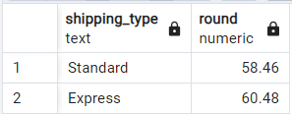

5. Subscribers vs. Non-Subscribers – Compared average spend and total revenue across subscription
status.
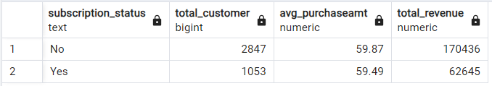

6. Discount-Dependent Products – Identified 5 products with the highest percentage of discounted purchases.
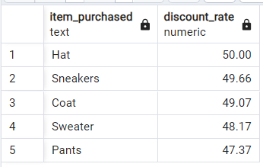

7. Customer Segmentation – Classified customers into New, Returning, and Loyal segments based on purchase history.
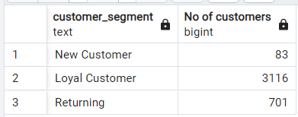

8. Repeat Buyers & Subscriptions – Checked whether customers with >5 purchases are more likely to subscribe.
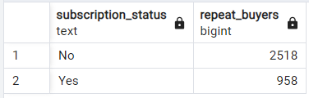

9. Top 3 Products per Category – Listed the most purchased products within each category.
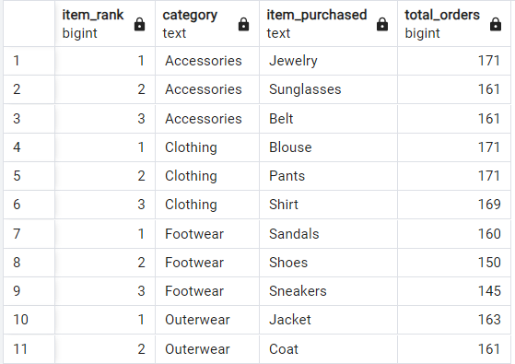

10. Revenue by Age Group – Calculated total revenue contribution of each age group.
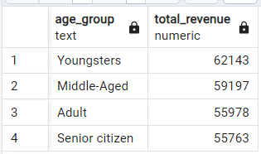

5. Dashboard in Power BI
Finally, we built an interactive dashboard in Power BI to present insights visually.
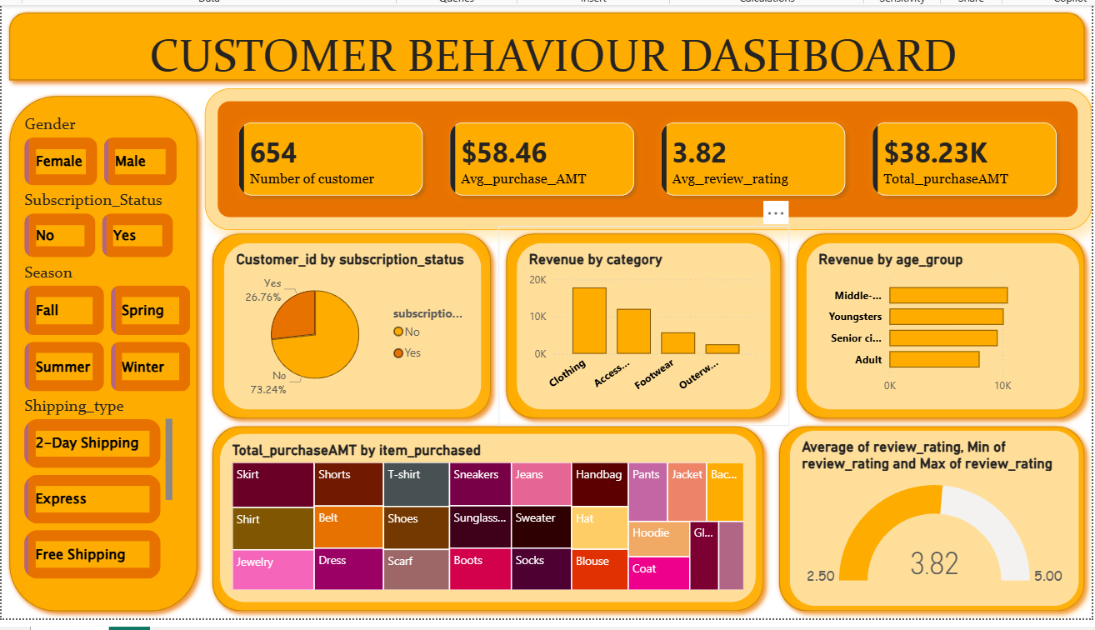

High-Level Metrics
- Customer Base: 654 customers analyzed.
- Revenue: Total purchase amount is $38.23K.
- Purchase Behaviour: Average purchase amount is $58.46.
- Customer Satisfaction: Average review rating is 3.82 (on a scale up to 5).
👥 Customer Segmentation
- Subscription Status: Majority (73.24%) are non-subscribers, while only 26.76% are subscribers.
- This suggests a potential opportunity to increase subscription adoption.
- Age Groups: Revenue is fairly balanced across Youngsters, Adults, Middle-aged, and Senior citizens, each contributing around 10K.
- This indicates broad appeal across demographics rather than reliance on one age group.
🛍️ Product Insights
- Top Revenue Category: Clothing dominates revenue compared to Accessories, Footwear, and Outerwear.
- Item-Level Purchases: Treemap shows diverse purchases — with Skirts, Shorts, T-shirts, Sneakers, Jeans, and Handbags standing out.
- This highlights fashion items as key drivers of sales.

🚚 Shipping & Seasonal Behaviour
- Filters allow analysis by shipping type (2-Day, Express, Free) and season (Fall, Spring, Summer, Winter).
- You can emphasize how these filters enable dynamic exploration of customer preferences.
⭐ Customer Experience
- Gauge chart shows average rating of 3.82, with a range between 2.5 and 5.
- This suggests room for improvement in customer satisfaction, especially for lower-rated experiences.

6. Business Recommendations
● Boost Subscriptions – Promote exclusive benefits for subscribers.
● Customer Loyalty Programs – Reward repeat buyers to move them into the “Loyal” segment.
● Review Discount Policy – Balance sales boosts with margin control.
● Product Positioning – Highlight top-rated and best-selling products in campaigns.
● Targeted Marketing – Focus efforts on high-revenue age groups and express-shipping users.

